CONCURSO INICIACIÓN 2011
FORMULARIO DE POSTULACIÓN

- Antecedentes generales
Título del proyecto | Ground-based remote sensing system for fog collector and environmental research
Investigador responsable | Richard LeBoeuf, Ph.D. |  | Contacto |  | 412-9622
Unidad Académica | Facultad de Ingeniería y Ciencias Aplicadas |  | Jornada |  | Full-time
Investigador patrocinante | Orazio Descalzi Muñoz  (see letter in Attachment 1) |  | Unidad Académica |  | Fac. Ingeniería y Cs. Aplicadas
Disciplina científica | Engineering and environmental science
Monto solicitado | Año 1 M$: 6507 | Año 2 M$: 1290 |  | Total M$: 7797
Financiamiento adicional | Fuente: N/A |  | Monto M$: N/A
Certificaciones y autorizaciones adjuntas | N/A
Resumen del proyecto (no más de 10 líneas)
Fog is of interest to researchers because of its detrimental effects on the usability of airports and roadways, because it sustains ecosystems that would otherwise not exist, and because it can be a source of water for development. This project will result in improved fog collection efficiency and advances in environmental science research through environmental sensing and fog collector system monitoring. Desert climate research has relied on spatially and temporally coarse data sets. Fog collectors have primarily resulted from humanitarian or local construction efforts with little to no optimization. This project requires the design, build, test, and deployment of a system for measuring environmental conditions including fog liquid water content and collector performance. The data from this system will support fog collector research, environmental research, and satellite remote sensing calibration.

Firma Investigador Patrocinante Firma Decano/Director

Firma Investigador Responsable

- Información curricular
Señale los antecedentes curriculares relevantes del investigador responsable de acuerdo al siguiente formato. Indique sólo los proyectos de investigación financiados con fondos concursables. Para proyectos de investigación y publicaciones, repita los recuadros que necesite, considerando el período de 5 años. No se considerarán los currículos que no se ajusten a este formato.

Nombre |  |  | Richard LeBoeuf
Título y Grados |  |  | B.S. Mechanical Engineering  B.S. Electrical Engienering  MBA  Ph.D. Mechanical Engineering |  | Año obtención grado |  |  | Ph.D. 1991
Proyectos de investigación (últimos 5 años)
Título: | N/A
Fuente de financiamiento: |  |  |  | Fecha inicio y duración: |  |  | Rol:
Título:
Fuente de financiamiento: |  |  |  | Fecha inicio y duración: |  |  | Rol:
Título:
Fuente de financiamiento: |  |  |  | Fecha inicio y duración: |  |  | Rol:
Título:
Fuente de financiamiento: |  |  |  | Fecha inicio y duración: |  |  | Rol:
Publicaciones (últimos 5 años)
Artículos ISI |  | 1. N/A  2.  3.
Artículos SCIELO |  | 1. N/A  2.  3.
Libros |  | 1. N/A  2.  3.
Capítulos de libros |  | 1. N/A  2.  3.
Otras informaciones de interés |  | 1. N/A  2.  3.

- Descripción del proyecto
Efectúe la descripción usando el mismo tipo y tamaño de letra de este formulario, con una extensión máxima de seis páginas, y siguiendo el orden que se señala a continuación.

Fundamentación del Proyecto: Describir y explicar: a) el contexto teórico del problema, b) los objetivos generales y específicos de la investigación, c) la o las hipótesis que se pretende verificar, y d) la metodología específica que se empleará.
a) El contexto teórico del problema
There are two purposes of this proposed project, to advance fog collector engineering and desert climatology. Persistent advection fog is created when clouds formed over the ocean hit elevated terrain. In Chile, fog results in fog oases (vegetación de lomas), unique and rich in biodiversity. They are ecologically endangered since the species are very fragile and depend mostly on fog. Global climate change may be a significant issue for these ecosystems. Conversely, they may be good indicators of this planetary change.

The fog has also been collected for development in desert regions. Fog collectors use a vertical mesh to collect and direct water from the air to a channel for collection or distribution (Figure 1). Fog collectors have primarily resulted from humanitarian efforts or local construction with little to no optimization. To optimize a system of fog collectors, it is necessary to understand the local environmental conditions.

Studies of desert fog have relied on remote sensing data (e.g., GOES), standard fog collectors (SFC, 1 m x 1 m vertical mesh), and some detailed measurements of liquid water content and droplet sizes. However, due to the remoteness of the region under investigation, detailed measurements have been sporadic or without fine temporal resolution. The research proposed here will enable scientists and engineers to obtain and analyze long-duration time-resolved measurements of desert atmospheric conditions including fog in their offices. | 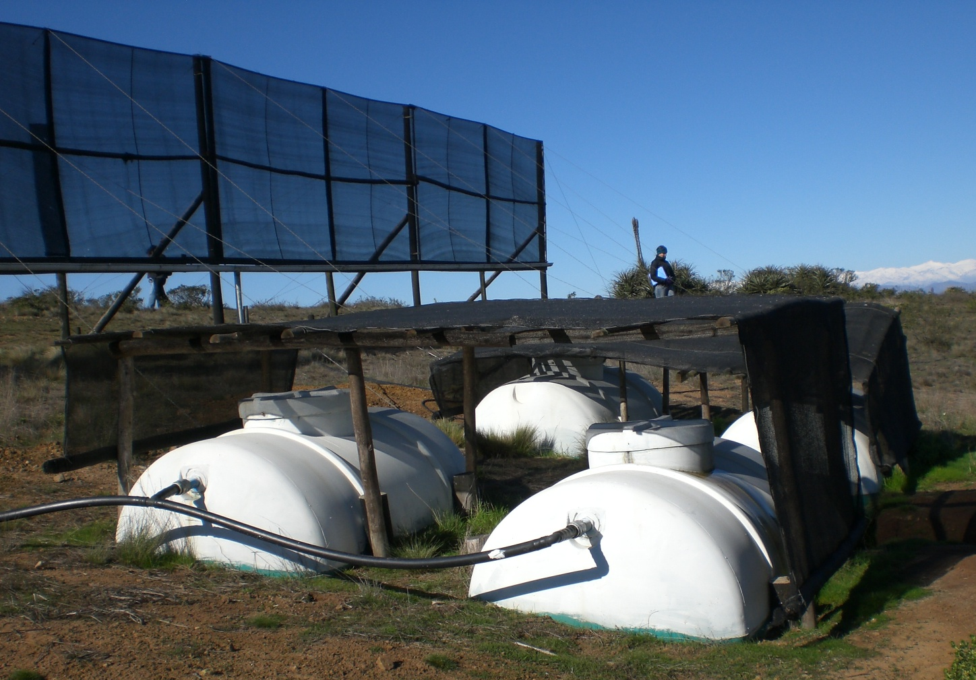 Figure 1. Fog Collector

b) Los objetivos generales y específicos de la investigación

General objective
This project will result in improved fog collection efficiency and advances in environmental science research particularly in the Atacama desert of Chile.

Specific objectives
The purpose of this project is to design, build, test, and deploy a ground-based system for measuring environmental conditions including fog liquid water content and fog collector efficiency. Unlike a standard weather station, the system will include sensors for fog detection and liquid water content measurement. In addition, it will monitor the production and condition of fog collectors. The system will be capable of remote operation by providing its own power, data collection, data logging and data distribution via satellite and internet communication.
c) Las hipótesis que se pretende verificar
This project will prove that a remote ground-based environmental sensing and collector monitoring system that supports fog collector research, environmental research, and satellite remote sensing calibration can be built at a reasonable cost.

d) La metodología específica que se empleará.
This project involves the design, build, test, and deployment of Ground-Based Environmental Sensing and Fog Collector Monitoring Systems (ESAMS). The proposed system is depicted in Figure 2. The component pictures are examples and not necessarily those that will be used in the actual system. The system has four subsystems: 1) environmental sensing instrumentation, 2) collector monitors, 3) data acquisition, and 4) power system. To minimize risk, commercial off-the-shelf (COTS) components will be used where they can be found at a reasonable cost and with appropriate specifications. Custom built components will include the fog detector, liquid water content probe, and some weather station components because of their needed duplicity in the deployed system.

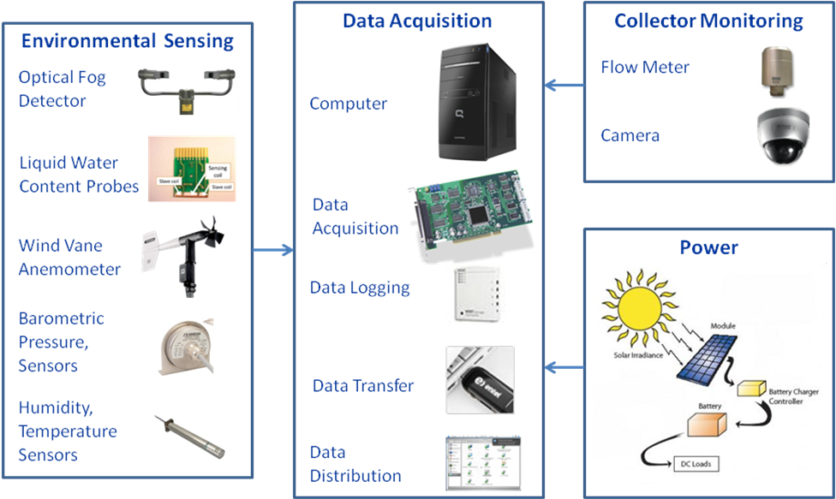

Figure 2. Ground-Based Environmental Sensing and Fog Collector Monitoring System (ESAMS)

The deployed system is depicted in Figure 3. Instrumentation is located upstream and downstream of a collector. Liquid water content (LWC) measurements are taken at various altitudes to enable optimization of collector shape and vertical location. The upstream and downstream LWC data can be used to estimate the collection efficiency, which is also related to the collector water output, which is measured using the flow meter of the collector monitor subsystem. In addition to the LWC hot wire probes, the upstream and downstream measurements include temperature, and wind speed and direction. These other data will be used for calculating the LWC based on the LWC hot-wire probe voltage and current measurements (i.e., the hot-wire power). Other environmental sensors (i.e., optical fog detector (OFD), pressure, humidity, and temperature) and the Power Subsystem will be located near the Data Acquisition Subsystem. Details of the subsystem components are given in Attachment 2. The subsystems will be tested individually and the integrated system will be calibrated at Pontificia Universidad Católica de Chile. The final system will be deployed in the Atacama Desert of Chile with data distributed via the internet.
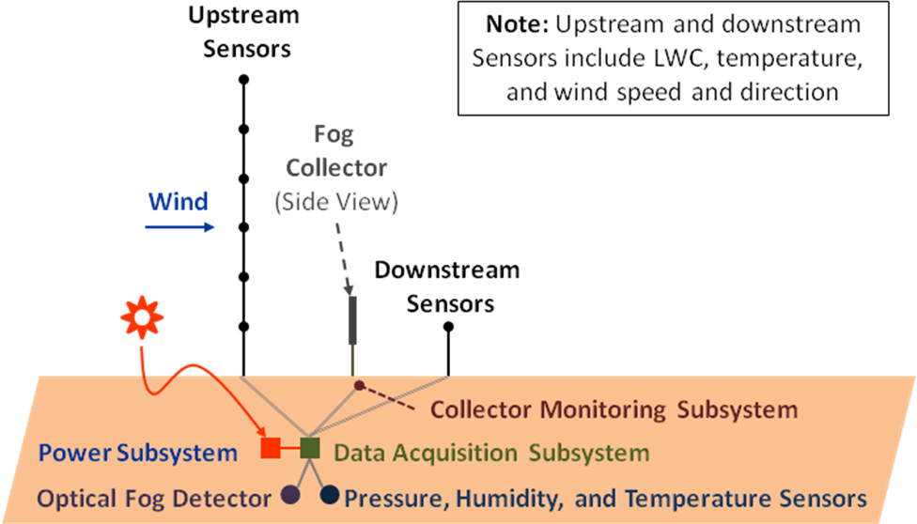

Figure 3. ESAMS Deployment Concept

Discusión Bibliográfica: Se solicita el análisis del estado de la cuestión en la bibliografía disponible teniendo en cuenta que no es suficiente el simple enunciado de títulos de libros y/o revistas.
Publications regarding environmental measurements and desert climatology provide the foundation for this project. Particularly relevant papers providing detailed information about instrumentation for fog measurements are included in the bibliography. In a series of papers (King, Parkin, & Handsworth, 1978; Bradley, & King, 1979; King, Maher, & Hepburn, 1981; and Biter, Dye, Huffman, & King, 1987), King, et al., gave clear direction for the design, construction, and accuracy of instrumentation for measuring LWC and droplet concentration and average size. While geared toward airplane mounted instrumentation, these references provide the foundation for developing the custom sensors and instrumentation for this ground-based application. Carrillo, Emert, Sherman, Herckes, & Collet (2008) gave the design and experimental results for an economical optical fog detector (U.S. $500). With careful calibration, it may also be useful for estimating the LWC. For this study, the fog detector will be used only to determine when the LWC probe should be powered. Therefore, this study will use the simple LWC hot wire probe technology along with a simple fog detector design (e.g., Fuzzi, Orsi, Bonforte, Zardini, & Franchini, 1997). The OFD design of Fuzzi, et al., uses backscattered light sensed with a phototransistor to detect the existence of fog.

The area of desert climatology and the effects of fog on the Atacama desert environment has been studied extensively by Pilar Cereceda, et al. Some particularly relevant papers that highlight the necessity for higher spatial and temporal resolution fog measurements and containing comprehensive bibliographies demonstrating an extensive history and interest in desert climate research include Schemenauer, & Joe, 1989; Schemenauer, & Cereceda, 1994; Osses, Farías, Núñez, & Cereceda, 2005; Cereceda, Larrain, Osses, Farías, & Egaña, 2008a&b. Very limited data sets using intermittent and aggregated measurements (e.g., from standard fog collectors) have been used to infer the relationship between fog and desert conditions like fog oasis. Remote sensing does not always provide the necessary resolution to fully develop and test the theories of desert climatology. Remote imaging is enhanced in combination with ground-based observations like those to be provided by this project.

Trabajo adelantado por los investigadores: Puede sustituirse este punto por consideraciones sobre la potencialidad de la investigación.
No references are listed in Section 2 for the past 5 years due to work in industry and a management program. However, the principal investigator (PI) has significant experience that supports his ability to carry out the work proposed. For example, the PI has experience designing and using hot-wire instrumentation for aerodynamics research and automating long duration measurements (NASA Ames Research Center/Stanford University Center for Turbulence Research). Relevant publications in the Journal of Fluid Mechanics, Physics of Fluids, Experimental Thermal and Fluid Science, and Experiments in Fluids are listed in the attached curriculum vitae (Attachment 3). In addition to relevant technical experience, the PI has ten years experience as an engineer and project manager, most recently in the process of designing, building, testing, and launching of a spacecraft attitude control system. The software and hardware testing processes are particularly relevant to the same phases of this project.

Relevancia y originalidad del Proyecto:
Relevancy: Fog is of interest to researchers because of its detrimental effects on the usability of airports and roadways, because it sustains ecosystems that would otherwise not exist, and because it can be a source of water for development. This project is relevant to both fog collector and climate research. Desert climate research in particular has relied on data from satellite remote sensing with very limited spatial resolution and very intermittent data and intermittent periods of live observation and measurements (Cereceda, et al., 2008b). The high resolution data has been intermittent because it required camping out in the field with the equipment and field trips to collect data from recorders. Fog collector research has relied primarily on low resolution data (from standard 1 m² fog collectors), which is typically obtained by hand by measuring the water collected over periods of days or weeks.

Originality: Unlike a standard weather station, the proposed system will measure characteristics of fog including liquid water content and droplet average size and concentration. These characteristics are commonly obtained on aircraft, but very intermittently obtained in ground sites except at some fixed atmospheric research laboratories. Furthermore, ground-based instrumentation for fog measurements typically consists of relatively expensive components. This proposal includes the development of inexpensive components, suitable for a ground-based observatory environment, to enable their use at many spatially separated locations.

This project will generate a system for collecting high-resolution environmental data in very remote locations automatically and make that data available in near real-time to researchers anywhere in the world via the internet.

Plan de Trabajo: Se solicita la descripción precisa de las etapas en que se desarrollará el trabajo y el tiempo estimado para cada una de ellas expresado en meses o trimestres.
The work plan is summarized in the table below. Every component acquisition is implicitly preceded by specification of requirements for that component and comparisons of candidate components. To the extent possible, a build a little, test a little philosophy will be followed to reduce development risk and obtain useful data as early as possible. That is, a partial system will be deployed as soon as possible and as each component becomes available it will be incorporated into that system. Note that the LWC probe design is currently in progress. Bibliographical research will continue throughout this project.

Activity | Year 1 |  |  |  | Year 2
Activity | Q1 | Q2 | Q3 | Q4 | Q1 | Q2 | Q3 | Q4
Environmental Sensing Subsystem
Design LWC probe & electronics | ✓
Build LWC probe & electronics | ✓
Test LWC probe and electronics |  | ✓
Integrate LWC probe and electronics |  |  | ✓
Design and build LWC probe rakes |  |  | ✓
Design Optical Fog Detector (OFD) | ✓ | ✓
Build OFD |  | ✓
Test OFD |  | ✓
Integrate OFD |  |  | ✓
Design wind vane anemometer (WVA) | ✓
Build WVA | ✓
Test WVA |  | ✓
Integrate WVA |  |  | ✓
Acquire and integrate humidity and pressure sensors |  | ✓
Collector Monitoring Subsystem
Acquire and integrate flow meters |  | ✓
Acquire and integrate cameras |  | ✓
Data Acquisition Subsystem (DAS)
Acquire hardware | ✓ | ✓
Design and code software |  | ✓
Design and implement data distribution |  | ✓
Test and integrate DAS |  | ✓ | ✓
Power Subsystem
Design power system | ✓ | ✓
Build power system |  | ✓
Test and integrate power system |  | ✓ | ✓
System Integration and Deployment
Integrate, test, and deploy full system |  |  |  | ✓
Monitor and distribute system output |  |  |  |  | ✓ | ✓ | ✓ | ✓
Publish Results
Probe and system design |  |  |  |  | ✓ | ✓
Measurements |  |  |  |  | ✓ |  |  | ✓

Otros aspectos relevantes: Pueden indicarse, por ejemplo, si se cuenta con financiamiento comprometido por fuentes externas a la Universidad de los Andes, o la trascendencia social de la investigación, o el abandono del tema por otras instancias, o la apertura de nueva línea de investigación, o la conformación de un equipo investigador o la colaboración de otras instituciones, entre otros aspectos.
Collaboration
This project will be performed in collaboration with the Acquaniebla Team of the Centro del Desierto de Atacama centered at the Pontificia Universidad Católica de Chile. Detailed letters of support from Juan de Dios Rivera, Ph.D., Professor, Mechanical Engineering and Pilar Cereceda, Ph.D., Professor, Geography are included in Attachment 1. The purpose of the Acquaniebla team is to optimize fog collection in the Atacama Desert of Chile.

Observation sites
Early deployment of the system will be in Peñablanca, VI Región, a site four hours drive from Santiago where integration can be completed in a stepwise manner. The site also has a rich history of fog collector use and research interest. Another system will be deployed in Alto Patache near Iquique, Chile where a set of 10 new fog collectors will be installed in the coming months. Both of these sites have cellular telephone service and biweekly visits by collector maintenance staff.

Security of deployed systems
Security of deployed systems will be enhanced by selecting very remote locations, containing electronics in locked cabinets firmly attached to the ground, using monitoring cameras, and limited amounts of live monitoring.

Compromiso de Publicaciones: Señale en detalle la o las publicaciones que se espera generar con el proyecto (artículos, libros, etc.), y la fecha estimada en que ello ocurriría para cada una de ellas. Se recuerda que conforme a las Bases del Concurso FAI 2011 la investigación deberá traducirse en al menos un artículo en revista ISI o Scielo.
Publications resulting from this project include papers about the instrumentation and analysis of the measurements resulting from its use. Submission of the following ISI publications is anticipated by the end of the second year of this project:

1. “A low-power fog liquid water content probe,” Experimental Thermal and Fluid Science.
2. “A remote ground-based environmental sensing and fog collector monitoring system,” Journal of Atmospheric and Oceanic Technology.
3. “Multiphysics modeling of a liquid water content probe,” Journal of Instrumentation or Flow Measurement and Instrumentation.
4. “Affects of salt accretion on liquid water content probe behavior,” Experimental Thermal and Fluid Science.
5. “Correlation of ground-based environmental measurements with satellite remote imaging,” Atmospheric Research.
6. “Liquid water content and velocity profiles in boundary layer fog,” Dynamics of Atmospheres and Oceans.

Results from this study would also fit very well into the 6th International Conference on Fog, Fog Collection and Dew in Yokohama, Japan, 2013, though this is outside the project scope.

- Recursos solicitados
Las cifras deben expresarse en Miles de pesos (M$) en los siguientes recuadros. A continuación deberá justificar la necesidad de la inversión solicitada. En los casos de viajes y bienes de capital deben adjuntarse las cotizaciones correspondientes.

A. Honorarios | M$ año 1 | M$ año 2 | M$ Total
Ayudantes o Tesistas | 1000 | 0 | 1000
Personal técnico o administrativo | 0 | 0
SUB TOTAL | 1000 |  | 1000

B. Pasajes y Viáticos | M$ año 1 | M$ año 2 | M$ Total
Pasajes |  | 360 | 360
Viáticos | 390 | 930 | 1320
SUB TOTAL | 390 | 1290 | 1680

C. Gastos de Operación | M$ año 1 | M$ año 2 | M$ Total
Material bibliográfico | 0 | 0 | 0
Materiales de laboratorio | 0 | 0 | 0
Bienes fungibles | 0 | 0 | 0
Pagos de servicios externos | 0 | 0 | 0
SUB TOTAL | 0 | 0 | 0

D. Bienes de Capital | M$ año 1 | M$ año 2 | M$ Total
Especificar (See Attachment 4) | 5117 | $0 | 5117
SUB TOTAL | 5117 | $0 | 5117

(A+B+C+D) | M$ año 1 | M$ año 2 | M$ Total
TOTAL | 6507 | 1290 | 7797

Justificación de los recursos solicitados

Honorarios:
Year 1
One electrical engineering student (thesis advisee with relevant microcontroller and solar power system experience) will help with the design, build, and test of the Data Acquisition and Power Subsystems for ten months at a rate of M$100 pesos per month.

Pasajes y viáticos:
Year 1
Two trips to Peñablanca, VI Región, a site four hours drive from Santiago. These trips each involve driving to Peñablanca from Santiago and camping out at the installation site for three days to install the equipment, perform post shipment tests, and monitor system performance. Two trips are necessary to install the system in two phases as components become available:

- Install first subset of system including weather sensing, collector monitoring, data acquisition, and power subsystems.
- Integrate liquid water content probe and fog detector.

Year 2
One trip to Peñablanca to retrieve the system for installation in Alto Patache.

Two trips to Alto Patache to perform system maintenance and calibration. These trips require round-trip air transportation from Santiago and accommodations in Iquique for one week the first trip and two days the second trip to dismantle. The purpose of the trip is to install a full suite of equipment, perform post shipment tests, and monitor system performance. The second trip is to retrieve the equipment.

Basis of Estimates:
Round trip to Peñablanca, VI Región using my own 4x4 vehicle, $130.000 pesos for fuel and tolls. Camp at the installation site.

Round trip to Alto Patache using flight on LAN Chile ($120.000) and Econorent 4x4 vehicle ($370.000 per week or $59.900 per day). Camp at the installation site. An additional 50% was added to cover taxes and fees.

Gastos de operación:
Expendable materials and regular operational costs are not needed for this project. Any materials or labor purchased for this project will be capitalized as part of the deployed systems and are therefore accounted for as Bienes de Capital.

Bienes de Capital:
Detailed cost estimates are given in Attachment 2. Make/buy justification is given in Attachment 4. At least one cost was found for each COTS component. Custom made component costs were estimated using their component and material costs and estimates of external labor required to complete the designs and produce parts.

- Posibles evaluadores y/o objeciones (OPCIONAL)

Si quiere, complete los siguientes recuadros que serán de utilidad para asignar a evaluadores externos.

Posibles evaluadores:
Señale los nombres y direcciones actualizadas de especialistas en el tema de la propuesta, chilenos(as) o extranjeros(as), que Ud. estima mejor calificados(as) para actuar como árbitros de su proyecto y con los cuales no tenga publicaciones conjuntas durante los últimos 2 años o relación de parentesco, profesional, comercial o tutor-estudiante. Esta información podría ser considerada por el Consejo de Investigación, al momento de designar evaluadores(as).

Posibles evaluadores

Nombre | Apellido Paterno | Apellido Materno | Contacto  (Teléfono/ E-Mail /Dirección)

Objeciones:
Señale los nombres de especialistas en el tema de la propuesta, chilenos(as) o extranjeros(as), que Ud. estima que presentan objeciones para actuar como árbitros de su proyecto. Esta información podría ser considerada por el Consejo de Investigación, al momento de designar evaluadores(as).

Objeciones
Nombre | Apellido Paterno | Apellido Materno

SE RECUERDA QUE ESTE FORMULARIO Y TODOS LOS ANTECEDENTES ADICIONALES, DEBEN SER PRESENTADOS EN DOS VERSIONES COMPLETAS: UN EJEMPLAR IMPRESO Y UNA VERSIÓN EN FORMATO PDF, DE ACUERDO A LO INDICADO EN LAS BASES DEL CONCURSO (Ver punto 6 ‘plazos y postulaciones’).
Bibliography

Biter, C. J., Dye, J. E., Huffman, D., & King, W. D. (1987). The drop-size response of the CSIRO liquid water probe. Journal of Atmospheric and Oceanic Technology, 4, 359-367.
Bradley, S. G. & King, W. D. (1979). Frequency response of the CSIRO liquid water probe. Journal of Applied Meteorology, 18, 361-366.
Carrillo, J. H., Emert, S. E., Sherman, D. E., Herckes, P., & Collet, J. L. (2008). An economical optical cloud/fog detector. Atmospheric Research, 87, 259-267.
Cereceda, P., Larrain, H., Osses, P., Farías, M, & Egaña, I. (2008a). The climate of the coast and fog zone in the Tarapaca Region, Atacama Desert, Chile. Atmospheric Research, 87, 301-311.
Cereceda, P., Larrain, H., Osses, P., Farías, M, & Egaña, I. (2008b). The spatial and temporal variability of fog and its relation to fog oases in the Atacama Desert, Chile. Atmospheric Research, 87, 312-323.
Fuzzi, S., Orsi, G., Bonforte, G., Zardini, B, & Franchini, P. L. (1997). An automated fog water collector suitable for deposition networks: Design, Operation and Field Tests. Water, Air, and Soil Pollution, 93, 383-394.
King, W. D., Maher, C. T., & Hepburn, G. A. (1981). Further performance tests on the CSIRO liquid water probe. Journal of Applied Meteorology, 20, 195-202.
King, W. D., Parkin, D. A., & Handsworth, R. J. (1978). A hot-wire liquid water device having fully calculable response characteristics. Journal of Applied Meteorology, 17, 1809-1813.
Korolev, A. V., Strapp, J. W., Isaac, G. A., & Nevzorov, A. N. (1998) The Nevzorov airborne hot-wire LWC-TWC probe: principle of operation and performance characteristics. Journal of Atmospheric and Oceanic Technology, 15, 1495-1510.
Osses, P., Farías, M., Núñez, R., & Cereceda, P. (2005) A methodology for validation of GOES information on fog distribution in northern Chile (ground truth). Geocarto International, 20, 69-74.
Schemenauer, R. S., & Joe, P. I. (1989). The collection efficiency of a massive fog collector. Atmospheric Research, 24, 53-69.
Schemenauer, R. S., & Cereceda, P. (1994). A proposed standard fog collector for use in high-elevation regions. Journal of Applied Meteorology, 33, 1313-1322.

Attachment 1. Letters of support
Letters of support from the patrocinante, Orazio Descalzi Muñoz of the Universidad de los Andes Facultad de Ingeniería and Ciencias Aplicadas is on the following page. In addition, letters supporting this proposal from Pilar Cereceda, Ph.D. and Juan de Dios Rivera, Ph.D., professors from Pontificia Universidad Católica de Chile in Geology and Mechanical Engineering, respectively, are on the following three pages.
Attachment 2. System Details
The proposed ground-based environmental sensing and fog collector monitoring system (ESAMS) was introduced in Section 3 and Figure 2. Note that in the figure, the components shown are examples and are not necessarily those that will be used in the actual system. The system has four main subsystems: 1) environmental sensing instrumentation, 2) collector monitors, 3) data acquisition, and 4) power system. To minimize risk, commercial off-the-shelf (COTS) components will be used where they can be found at a reasonable cost and with the appropriate specifications.

Some details of the subsystem components are given in the following subsections. Most of the detailed design will be done in the months leading up to and in early months of this project.

Environmental Sensing Subsystem (ESS)
The Environmental Sensing Subsystem (ESS) will include instrumentation for measuring the environmental conditions including: pressure, humidity, temperature, wind speed and direction, fog detection, and liquid water content. Each component of the ESS is described below along with the likely make/buy decision justification.

Optical Fog Detector (OFD)
The presence of fog will justify powering the liquid water content (LWC) probe. Commercially available fog detectors are expensive and typically have high power consumption (e.g., US$18,000 for a Automatic Power, Inc. model with low power). They typically have built-in control functions required in the event of fog detection (e.g., illuminating warning signs). However, several low cost fog detection designs are described in the literature (e.g., Carrillo, et al., 2008). Fog detectors operate on the basis of attenuation or scatter of light. Therefore, a simple LED/phototransistor-based optical fog detector will be designed and built for this project.

Liquid Water Content (LWC) Probe
Commercially available components for measuring liquid water content (LWC) include Particulate Volume Monitor (PVM, e.g., Gerber Scientific PVM-100), Forward-scattering spectrometer probes (FSSP, e.g., Droplet Measurement Technologies FSSP-100), and LWC hot-wire probes (often referred to as King probes, e.g., Droplet Measurement Technologies LWC-100). Due to their high cost and high power requirements, FSSP and PVM are not suitable for this project. Similarly, commercially available liquid water content probes are expensive (about US$12,000 for one probe) and designed for use on an aircraft (at much higher velocities and with high power consumption). Therefore, a new hot-wire probe will be designed and built for this project. The LWC probe and electronics designs will be based on the King probe design elaborated on in several papers (King, 1978; Bradley and King, 1979; King, Maher & Hepburn, 1981 and Biter, Dye, Huffman, & King, 1987). In addition, the probe will be placed on a vane to help stabilize flow characteristics of the sensor by directing the probe into the wind (Korolev, Strapp, Isaac, & Nevzorov, 1998).

The temperature and velocity measurements will be used in conjunction with the LWC probe power (computed from the wire voltage and current outputs) to estimate the air liquid water content. Therefore, a thermistor will be integrate into the LWC electronics design (e.g., with the Microchip MCP9700/9700A Low-Power Linear Active Thermistor Integrated Circuits to convert temperature to an analog voltage. A wind-vane anemometer (described below) will be located close to each LWC probe. Since the LWC varies with altitude (Cereceda, Larrain, Osses, Farías, & Egaña, 2008b), this subsystem will include simultaneous measurements of temperature, velocity, and LWC at multiple vertical positions using a probe rake (Figure 3).

Wind Vane Anemometer
A wind vane anemometer will be used to measure the air speed and direction at each LWC probe locations. Wind vane anemometers have the advantage over cup anemometers that they can operate into a lower velocity range (on the order of 1 m/s). Due to the multiplicity needed for this project, Commercial wind vane anemometers are too costly for this project (e.g., R. M. Young Wind Monitor Model 05103 for US$1,200). Therefore a simple design utilizing a potentiometer to sense wind direction and a generator or pulse output to estimate wind speed will be designed, built, and calibrated at the Pontificia Universidad Católica de Chile.

Humidity Sensor
A standard COTS humidity sensor will be used for this project (e.g., Humidity/Temperature Sensor with USB Connection, Omega part number RH-USB). One humidity sensor is needed for each ESAMS.

Barometric Pressure Sensor (0 - 5 V)
A standard COTS barometric pressure sensor will be used for this project (e.g., 0 - 5 V, Omega part number PX2760-600A5V). One barometric pressure sensor is needed for each ESAMS.

Collector Monitoring Subsystem (CMS)
The Collector Monitoring Subsystem (CMS) will include flow meters and cameras, which are described below.

Flow Meter
Historically, rain gauges have been used to measure the water captured by fog collectors. However, measurements were recorded manually at 1 to 3 day intervals using measurements of accumulation in a bucket or using a data logger with a tipping bucket rain gauge. A standard COTS flow meter will be used for this project (e.g., R. M. Young, Model 52203). The bucket rain gauge and, possibly, specially designed flow meters (currently being designed at Pontificia Universidad Católica de Chile and not included in this proposal) will be interfaced with the data acquisition subsystem to provide access in near real-time to fog collector flow rates. One flow meter is needed for each ESAMS.

Cameras
The CMS will also include cameras for monitoring the integrity of collectors and the ESAMS. The cameras, commonly used to monitor houses over the internet, will be controlled in the same manner through cellular telephone technology. A standard COTS camera will be used for this project (e.g., Panasonic BB-HCM531A Outdoor Pan/Tilt PoE Security Network Camera). One camera will be placed such that it can be controlled to view the collector and the ESAMS.

Data Acquisition Subsystem (DAS)
The Data Acquisition Subsystem (DAS) must collect, store, and distribute the measurements from the ESS and CMS. It will include standard COTS data acquisition hardware and software, data loggers, and technology (e.g., an embedded Global System for Mobile Communications (GSM) card) to transmit data via a standard cellular telephone service. Coordination of all functions will be controlled by the computer, which may be a standard computer or an embedded microcontroller (to minimize power consumption). Date and time stamped data will be made available to researchers via the internet using Dropbox.com or another COTS data sharing tool. The DAS will be designed for future possible expansion to include additional types or larger numbers of probes.

The interface requirements for the DAS are listed in Table 1. A total of 41 analog inputs, 1 USB, and 1 Ethernet connections are required. Rather than a PC-based architecture, a microcontroller based solution is assumed for this subsystem because of its low power (which reduces the cost of the Power Subsystem) and relatively low cost. An Arduino-based architecture is included in the costing. Arduino is an open-source physical computing platform based on a simple I/O board and a development environment that implements the Processing/Wiring language. The open-source integrated development environment (IDE) can be downloaded for free for Mac OS X, Windows, and Linux.

Table 1. Data Acquisition Subsystem (DAS) Inputs and Outputs (I/O)

Peripheral Device | DAS Requirement | Data Rate
Environmental Sensing Subsystem
Optical Fog Detector  (1 per system) | 2 analog inputs (Source and backscatter detector voltages) | 1 per minute
LWC probe with RTD  (7 per system) | 21 analog inputs (Hot wire voltage and current (as a resistor voltage) and RTD bridge voltage) | 1 per minute
Wind vane anemometer  (7 per system) | 14 analog inputs (Wind direction and speed voltages) | 1 per minute
Humidity sensor  (1 per system) | 1 USB (with humidity and temperature) | 1 per minute
Barometric pressure sensor  (1 per system) | 1 analog input (voltage) | 1 per minute
Collector Monitoring Subsystem
Bucket rain-gauge flow meter  (1 per system) | 1 digital input (magnetic reed switch) | Up to 1 per second
Custom flow meter (Pontificia Universidad Católica de Chile)  (1 per system) | 1 analog input | 1 per minute
Camera | 1 Ethernet (10Base-T/100Base-TX) (image inputs, pan and tilt outputs) | Commanded
Power Subsystem
Solar cell output | 1 analog input | 1 per minute
Battery state of charge | 1 analog input | 1 per minute

Each component of the DAS is described below.

Central Computer
The Arduino Mega is a microcontroller board based on the ATmega2560. It has 54 digital input/output pins (of which 14 can be used as PWM outputs), 16 analog inputs, 4 UARTs (hardware serial ports), a 16 MHz crystal oscillator, a USB connection, a power jack, an ICSP header, and a reset button.

Analog Input Card
The Mux (Multiplexer) Shield adds the capacity for up to 48 inputs or outputs on the Arduino Mega. Using three Texas Instruments CD74HC4067 Analog Multiplexers, the Mux Shield makes it possible to have 48 analog/digital inputs or digital outputs in many configurations.

Ethernet Interface Card
The Arduino Ethernet Shield allows an Arduino board to connect to the internet. It is based on the Wiznet W5100 Ethernet chip providing a network (IP) stack capable of both TCP and UDP. The Arduino Ethernet Shield supports up to four simultaneous socket connections.

Cellular Telephone Interface Card
The Cellular Shield for Arduino includes all the parts needed to interface the Arduino with an SM5100B cellular module. This enables the addition of SMS, GSM/GPRS, and TCP/IP functionalities to the Arduino architecture. The SIM card from a cell phone service provider needs to be added.

SD Memory Interface Card (Data Logger)
The microSD Shield equips the Arduino with mass-storage capability, so it can be used for data-logging. Communication with microSD cards is achieved over an SPI interface. The shield comes populated with a microSD socket, red power indicator LED, and a reset button. The total data collected per day will be approximately 120 MB. Therefore, an SD memory card will hold about 2 weeks of data. This is only needed in the event that a communication failure occurs. Otherwise, the data will be refreshed after its distribution via the internet is confirmed.

Also included in the costing are the cables, SD cards, connectors, and cellular telephone service.

Power Subsystem (PS)
The Power Subsystem (PS) will collect, store and distribute energy from the environment. Given the relatively low wind speeds in the regions of interest, the system will use solar collectors. The power system will be sized according to the total loads in the system and the available sun light and storage capacity necessary in worst-case (winter) solar conditions. All other subsystems will be optimized to reduce the cost of this subsystem, which is driven directly by power consumption.

An estimate of the total power budget is given in Table 2. The peak power required is about 65 Watts. However, it should be noted that the LWC probes are the highest power consumers in the system and they will be powered off in the absence of fog. Preliminary design has shown that the power will be less than 5 W per LWC probe including the thermistor. Furthermore, the LWC probes will be designed to be low power and remain within the budgeted power and energy of to accommodate economical Power Subsystem components.

Table 2. Approximate Power Budget

Peripheral Device | Power Requirement (W)
Environmental Sensing Subsystem | 35
Collector Monitoring Subsystem | 10
Data Acquisition Subsystem | 10
Power Subsystem (inefficiencies) | 10
 | Total power: 65 W
Each component of the 12-Volt Power Subsystem is described below.

Solar Panel
The candidate photovoltaic solar panel is designed for use with a 12 Volt battery and provides about 115 W in full sun. Two panels per system are included in the costing. However, an effort will be made to design components such that one solar panel will be sufficient under worst-case conditions (e.g., cloudy winter days.

Battery Charge Controller
The battery controller will maintain the battery state of health through controlling the state and rate of battery charging.

Battery
Assuming worst-case that the system must have the capacity to store 12 hours of operating energy, then the battery should store about 100 Ah, the capacity of the selected battery.
Attachment 3. Curriculum Vitae of the Principal Investigator
The CV for Richard LeBoeuf is included as the following 8 pages.

Attachment 4. Detailed Cost Estimates
Detailed cost estimates are included in the table below. Supplier cost information is included on separate pages following the table.

Table 3. Cost Details for Capital Equipment

Component | Unit Cost (M$) | Quantity | Total Cost (M$) | Basis of Estimate
Environmental Sensing
Optical Fog Detector | 270 | 1 | $270 | PCB layout, PCBs, and electronics components (LEDs, phototransistors, resistors, etc.)
LWC probe with thermistor and electronics | 131 | 7 | $920 | Estimate from DICTUC for final electronics design, PCB layout, PCBs, and electronics components, nonrecurring costs were averaged and included per unit
Wind vane anemometer | 121 | 7 | $850 | Metal, generator, bearings, machining, nonrecurring costs were averaged and included per unit
Humidity sensor (Humidity/Temperature Sensor with USB Connection) | 102 | 1 | $102 | Omega Part number RH-USB with factor of 1.5 for IVA, shipping, and potential changes in currency exchange
Barometric pressure sensor (0 - 5 V) | 278 | 1 | $278 | Omega Part number PX2760-600A5V with factor of 1.5 for IVA, shipping, and potential changes in currency Exchange
Probe Tower |  |  | $278 | Tubing, cable, fitting, connectors, lightning protection (Sodimac: Perfil tubular redondo 1 1/2 pulgada x 2 mm x 6 m, alambre galvanizado multiuso #18 20 m, hormigon)
Collector Monitoring
Flow meter (Tipping Bucket Rain Gauge) | 329 | 1 | $329 | R. M. Young Model 52203 (unheated) with factor of 1.5 for IVA, shipping, and potential changes in currency exchange
Camera | 376 | 1 | $376 | Panasonic BB-HCM531A Outdoor Pan/Tilt PoE Security Network Camera with factor of 1.5 for IVA, shipping, and potential changes in currency exchange
Data Acquisition
Central computer | 47 | 1 | $47 | Arduino Mega 2560  (includes 54 digital I/O, 16 analog inputs and a USB interface)
Analog input card | 18 | 2 | $35 | Mayhew Labs Mux Shield (48 analog inputs) with factor of 1.5 for IVA, shipping, and potential changes in currency exchange
Ethernet interface | 31 | 1 | $31 | Arduino Ethernet Shield
Cellular telephone interface | 65 | 1 | $65 | Spreadtrum Cellular Shield with SM5100B
SD card interface  (data logger) | 10 | 1 | $10 | Sparkfun.com Arduino microSD Shield
Cellular telephone service | 920 | 1 | $920 | Entel: Modem + monthly service for 21 months
Miscellaneous | 100 | 1 | $109 | Cables, SD cards, connectors, enclosures
Power System
Solar Panel | 237 | 1 | $237 | Photovoltaic Solar Panel 115W, for 12V batteries
Battery Charge Controller | 80 | 1 | $80 | Victron Battery Charger 12/7 IP20 12V 7A
Battery | 130 | 1 | $130 | Battery 12V 100Ah Curtiss CT121000 AGM Deep Cycle
Miscellaneous | 50 | 1 | $50 | Power cables, connectors, and mounting hardware
 |  |  | Total $5117

